**Reading 5 – Sjoerd Herlaar**

1. **Ware argues that human perception involves 2.5 dimensions. Given this assertion, when might a 3D visualization be useful and why?**

2.5 dimension vision is created through shadows and relative size for instance. For most things in life, 3D vision would not be very useful since there is more information to be found in the up and down, and sideways dimensions then in the away dimension as Ware puts it. Even though this is the case, there are some situations in which 3D vision would actually help. Because we have 2.5D vision, we do not really have a 3D model of objects in our memory, they are all stored as a 2D image. Carpenters and other men of craft would be able to work easier and more efficiently if they could see in 3D and be able to store certain images in 3D in their brain. It is shown that these people actually have a more developed skill when it comes to 3D structuring in their minds. 3D visualization might help them even further and for Engineers it does because of the use of 3D modelling.

1. **In Chapter 6, Ware presents some implications of pattern recognition and visual working memory on design. Provide an example that harnesses some of these principles (perhaps an advertisement, visualization, or interface) and discuss how the design takes these principles into account. Please include a screenshot, photo, or website URL.**



The picture above shows a set of vegetables that are arranged in the shape of a happy face. By doing this, the advertiser that might use this picture tries to combine the feelings associated with vegetables to that with the feeling associated with someone smiling; a positive feeling. Through this, an advertiser might create a different mind-set towards its product and so increase sales.

1. **According to Bostock et. al., what are the primary advantages of D3? Based on your reading of the article, please provide an example of a type of visualization that would be easier and better implemented in D3 as opposed to HTML5, JSON, and Javascript. Please list the pros and cons of choosing D3 over pure HTML5, JSON and Javascript.**

The article presents some solid advantages as well as disadvantages for using D3, one of which is the fact that using D3 will result in significantly faster loading times as opposed to Protovis or Flash and is easier to debug. These are not the only advantages D3 has over other methods; there is a vast amount of possibilities for visualization that D3 can produce that other Toolkits cannot. This comes at cost though, since lesser options means more focus per visualization option. This is why Flash outperforms D3 in terms of framerate, especially when more datapoints are added.

1. **Of the visualization figures presented in Heer et. al., which do you find the most difficult to comprehend? Does the complexity of the figure interfere with the goal of visualization as described in the article? Include a screenshot of the figure you have chosen in your response and use principles that you have learned so far (i.e., from design, perception, and cognition) to justify your choice.**

Personally, I find the stacked graph the hardest to comprehend because it is difficult to find which stack creates what trend. After investigating the different areas, at first I thought the light green area created the wave-like trend that can be seen in the screenshot below but after giving it a second look this does not seem to be the case. If I see things correctly, and I hope I do, the trend is caused by the construction area. In my opinion this is the biggest problem this visualization has; trends can be seen, but the cause of the trend can be very unclear on first sight.

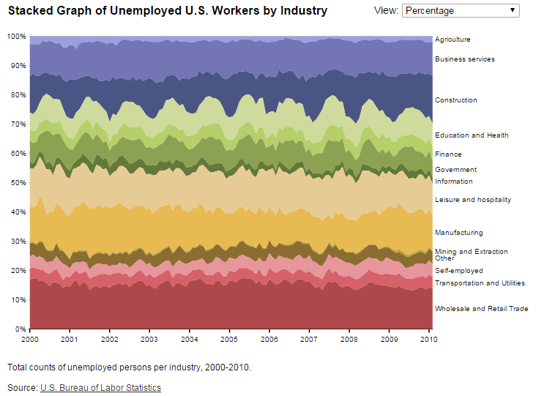

1. **Play around with the interactive graphs included in the Heer article. You need to open this page in a browser that runs Java. Focus on Figure 1A. To what extent do interactivity and transitions, elements that D3 optimizes, add to the clarity and message of the visualization? With the element of interactivity in mind, redesign and sketch the contents of figure 1A with one of the other visualization types described in the Heer article. Include a picture of a sketch of your idea, and describe how it supports comprehension and data exploration.**

After checking figure 1A in the article, it becomes clear that moving the crosshair will result in a changing Y-axis, something that can create a lot of miscommunication and is just plain annoying. The scale on the Y-axis can differ from 0% up to 200% to 0% to 3000%, which is a huge difference. The graph itself takes some getting used to too since the crosshair is the normalized price of the stock, something that is not very familiar with people not focused on economics. My suggestion is to keep the Y-axis on a fixed scale, something like 0% to 500% or 0% to 1000% and change the data instead of the axis. Graph 1D shows how data can be changed while keeping a fixed Y-axis by showing gradients of colour for the amount of times the maximal Y-axis value has been passed. This way, the data can change and show different info whilst moving the crosshair without changing the Y-axis.